MEAL CONNECT
  - Project Overview & Architecture Notes
JIRA MEAL-197 | Sprint 1: 28 October–3 November 2026 | Draft v1.0 | 30 October 2026
Document status: REVIEW DRAFT. This describes the agreed MVP and proposed technical design; it does not claim that the application features have been coded or tested. Approval and final as-built update are pending.

1. Goal and acceptance criterion
MEAL-197 task: “Describe stakeholders, major features, stack, and data flow.” Acceptance criterion: “Documentation reflects the implemented system.” The repository currently has an initial scaffold, while application modules are planned for Sprints 2–7. Reconcile this document with the running code before declaring the final as-built requirement met.

2. Product overview and scope
Meal Connect is a localhost-demonstrated, browser-based platform to connect restaurant/bakery surplus food with verified NGOs and volunteer collectors. A business publishes an available food listing; an NGO selects a quantity from that existing listing and requests it; the owning business fully approves or rejects it; an assigned collector coordinates pickup/delivery; the NGO records distribution. Reports use saved activity. General NGO food-wanted postings and partial approval are not part of the agreed MVP.

Actors and responsibilities
Actor | In-scope responsibility
Restaurant / Bakery | Register/profile; after verification, create/edit/cancel surplus-food listing and approve or reject NGO quantity requests.
Verified NGO / Charity | Find/filter available listings; request selected quantities; track collection; record distribution and beneficiary counts.
Volunteer / Collector | Access assigned pickups and update pickup and delivery statuses.
Administrator | Verify organizations; manage users/listings/requests; moderate questionable records; view basic impact reports.
Beneficiaries | Receive food through NGOs; no login/account in this MVP.

Included / excluded boundaries
Included: registration and login, hashed passwords, roles and organization verification; donations and search; NGO requests; full approval/rejection with safe stock allocation; pickup and distribution; in-app notifications; administration; basic persisted-data reporting; mobile-responsive browser interface.
Excluded: native mobile apps, payments/fundraising, AI matching/prediction, live GPS or delivery-provider integration, QR pickup confirmation and production cloud deployment. Food-safety certification is not promised by the system.

3. Architecture: logical three-tier design
Presentation (HTML/CSS/JavaScript/Bootstrap) → application (FastAPI REST endpoints, authorization, validation and services) → persistence (PostgreSQL; SQLAlchemy and Alembic proposed). The frontend must not connect directly to PostgreSQL, nor be authoritative for authorization or quantity/state changes.
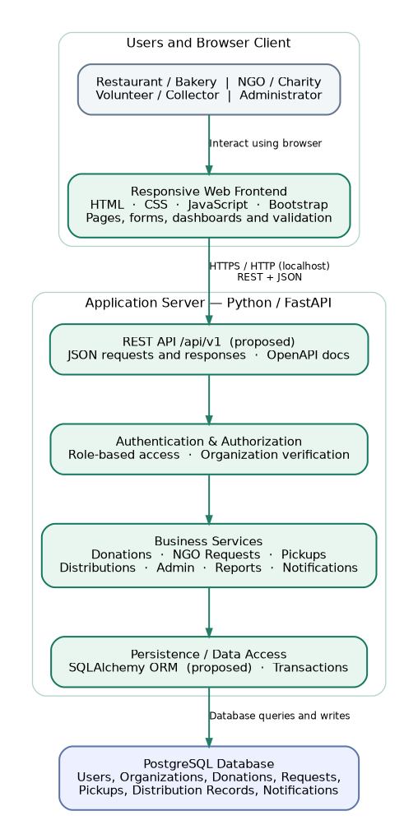
Figure 1. High-level logical architecture (MEAL-61; proposed, not a deployed network diagram).

Component responsibilities
Layer / module | Boundary / responsibility
Frontend | Responsive role-based pages, forms, search/filter UX, API calls, display validation/errors.
FastAPI routes | Versioned HTTP/JSON interface, request parsing, auth dependencies and response codes.
Domain services | Organization verification, donation availability, NGO request decisions, collector status changes, distribution confirmation, notifications and report rules.
Data access / PostgreSQL | Entities, foreign keys, unique/check constraints, migrations, audit timestamps, concurrency-safe stock transactions.

4. Core workflow and quantity rules
1. Business organization is approved; authorized staff publish an available donation with quantity, safety disclosures, pickup address and deadline.
2. Verified NGO browses a listing and requests any valid quantity not exceeding current available quantity. This is a request against an existing donation, not a separate general demand posting.
3. Owning business approves ALL requested_quantity or rejects the request. No approved_quantity column or partial approval is needed.
4. Upon approval, reserve exactly requested_quantity, under a single transaction with row locking/atomic conditional update, preventing over-allocation during simultaneous decisions.
5. Approved request is assigned to a collector; pickup/delivery progress is recorded; NGO records final distribution; reports use actual persisted completion records.

Example
Event | Quantity (portions)
Restaurant publishes | 100
NGO requests | 30
Business approves the full request | 30
donations.allocated_quantity increase | 30
Remaining available | 70
Do not accept requests for expired/cancelled donations. An approved cancellation before collection may release allocation once, using the same transaction; release after collection needs an explicitly approved reversal policy. These controls are design rules, not yet implemented.

5. Data model and logical relationships
The reviewed MEAL-6 baseline contains ten tables: users, organizations, organization_memberships, organization_verifications, donations, donation_requests, pickups, distribution_records, notifications and status_history. The DBML source is the schema-design authority; this document is only an overview.
Relationship / condition | Intended rule
users ↔ organizations | Many-to-many through organization_memberships, unique organization/user pair.
organization → donations | A verified business organization owns many donations; individual creators recorded.
donation → donation_requests | One donation has many requests from verified NGOs.
request → pickup | Zero or one pickup per request (UNIQUE pickups.request_id).
pickup → distribution_records | Zero or one final distribution per pickup (UNIQUE distribution_records.pickup_id).
quantity / history | allocated_quantity between zero and total_quantity; transactions and status_history trace approvals.
Database validation beyond simple table-local constraints (for example membership authorization, allowed status transitions and cross-table distribution amount) must be implemented by backend service logic and/or database triggers in later sprints.

6. API conventions and integration guidance
Topic | Current proposed convention
Base path | /api/v1; localhost example http://localhost:8000/api/v1
Data | JSON UTF-8; snake_case properties; timezone-aware ISO 8601 timestamps
Resource naming | Lowercase plural paths, IDs as path variables
Methods | GET read; POST create/action; PATCH partial change; DELETE only where approved
Auth | Server-side role, active membership, organization type/verification and ownership checks; JWT proposed, not selected
Success | 200/201/204 as appropriate
Errors | 400, 401, 403, 404, 409, 422, 500; consistent safe machine-readable error envelope proposed
API documentation | FastAPI OpenAPI /docs once backend is implemented
Illustrative (not implemented): GET /api/v1/donations; POST /api/v1/donations; POST /api/v1/donations/{donation_id}/requests; POST /api/v1/requests/{request_id}/approve; PATCH /api/v1/pickups/{pickup_id}; GET /api/v1/reports/impact. Final route names and error shape must follow the MEAL-62 review decision.

7. Development environment and repository
Development target: Windows localhost per MEAL-63 and MEAL-163. Proposed baseline Python 3.12.x, PostgreSQL 16.x, FastAPI/Uvicorn, optional SQLAlchemy/Alembic, Git/GitHub, Postman and editor (VS Code or PyCharm). Exact versions and dependency pins are not confirmed; do not claim a reproducible backend until requirements and smoke tests exist.
MEAL-161 GitHub repository: https://github.com/rivipahanviksura/meal-connect (private). Existing scaffold: frontend/, backend/app/{api,models,schemas,services}/, backend/tests/, database/, docs/, README.md and .gitignore. Branches: main (stable), develop (integration); members should use feature branches and pull requests. Repository contents beyond the confirmed scaffold are not verified here.
Suggested later additions (not yet established in repository): backend/app/core, backend/app/db, backend/app/security, backend/alembic, backend/requirements.txt, and secret-free .env.example. Avoid committing .env, secrets, virtual environments or database dumps.

8. Sprint mapping and handoff
Sprint | Expected milestone / status
1 · 28 Oct–3 Nov | Requirements, ERD, architecture, user journeys, wireframes, repository scaffold; documents drafted for review.
2 · 4–10 Nov | Local application setup, PostgreSQL, authentication, roles, organization verification.
3 · 11–17 Nov | Donation create/edit/cancel; browse, search, filtering.
4 · 18–24 Nov | NGO quantity requests and full approve/reject with allocation checks.
5 · 25 Nov–1 Dec | Pickup and NGO distribution workflow.
6 · 2–8 Dec | Admin, basic in-app notifications, recorded-data reporting.
7 · 9–15 Dec | Integration, security, QA, documentation.
Final · 16–18 Dec | Final verification, demo and submission.

9. Decisions, risks and as-built verification
Item | Status / owner action
Full approve or reject; no general NGO request posting | Agreed MVP business rule; communicate to all feature owners.
Database schema and migration constraints | MEAL-6 design documented; implement and test in Sprint 2.
Auth mechanism and token expiry | Proposed JWT; backend/team must select and record final contract.
Exact dependency pins, module paths, status enums | To confirm alongside MEAL-63/163 and ERD/API owners.
Concurrent approval, expiry, cancellation | Critical implementation/testing tasks; do not treat design notes as tested software.
Architecture/API and supervisor sign-off | Pending review; update diagrams and this note on decisions.
As-built documentation reflection | Pending actual code and local running-app verification; revisit before final Done.

Review checklist — MEAL-197
☐ Stakeholders and MVP features match approved scope
☐ Architecture diagram and module boundaries match MEAL-5 and MEAL-61
☐ Entity references/quantity rules match MEAL-6 DBML and decision note
☐ API examples and error conventions match MEAL-62
☐ Repository layout and version assumptions checked with actual GitHub and MEAL-63/163
☐ Running implementation checked and any differences recorded
☐ Team/supervisor review and sign-off recorded
Reviewer: _____________________ Date: _______________ Decision: Approved / Revisions required

10. Source documents
Meal Connect Project Proposal; MVP Scope v1.1 & Prioritized Requirements; MEAL-5 Architecture; MEAL-61 High-Level Architecture; MEAL-62 API Conventions; MEAL-6 Reviewed DBML / Notes and Full Approval–Reject Decision; MEAL-63 Backend Configuration v1.1; MEAL-163 Prerequisites and Versions; MEAL-161 repository scaffold; Sprint Assignment CSV, task #197.

